Student Performance Analytics System
Project Documentation

1. Project Objective
The objective of this project is to analyze students’ academic performance using Python. The program reads student data from a CSV file, calculates total and average marks, assigns grades, identifies pass/fail results, summarizes class performance, compares subject averages, identifies the top three students, and analyzes attendance.

2. Technologies Used
- Python — programming language
- Pandas — reading and analyzing tabular student data
- NumPy — performing numerical operations and pass/fail checks
- CSV — storing the student dataset
- Google Colab — testing and running the program
- GitHub — storing and sharing the project files

3. Project Files
Main.py — contains the Python source code.
Students.csv — contains student IDs, names, departments, subject marks, and attendance.
README.md — explains the project, its features, files, and how to run it.

4. Dataset Description
The dataset contains 20 student records. The columns are Student_ID, Name, Department, Math, Python, AI, and Attendance. Math, Python, and AI are the three subjects used to calculate total marks and average marks.

5. Implementation
- Load Students.csv using Pandas.
- Calculate each student’s total marks across Math, Python, and AI.
- Calculate each student’s average marks.
- Assign grades using the program’s thresholds: A+ for 90 and above, A for 80–89.99, B for 70–79.99, C for 60–69.99, D for 40–59.99, and F below 40.
- Mark a student as Pass when all three subject marks are at least 40; otherwise mark the student as Fail.
- Display class statistics, subject-wise averages, top three students, and average attendance.

6. Results
Metric | Result
Total students | 20
Class average | 79.77
Highest student average | 94.33
Lowest student average | 59.33
Students passed | 20
Students failed | 0
Math subject average | 78.00
Python subject average | 80.40
AI subject average | 80.90
Average attendance | 87.80
Top 3 students | Sai (94.33), Shaurya (93.00), Anaya (92.67)

7. How to Run the Project
Keep Main.py and Students.csv in the same folder. Install Python, Pandas, and NumPy if they are not already installed. Run the program with: python Main.py
In Google Colab, upload or create Students.csv in the session and run the code cell containing the program. If the session resets, the CSV may need to be uploaded again.

8. Output Screenshots
Insert screenshots of the program output here before final submission. Include the full student results table and the sections showing class statistics, subject-wise averages, top three students, and attendance analysis.

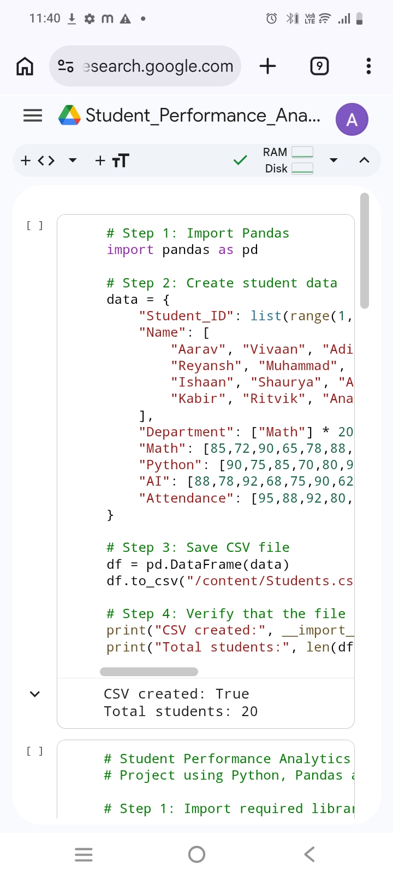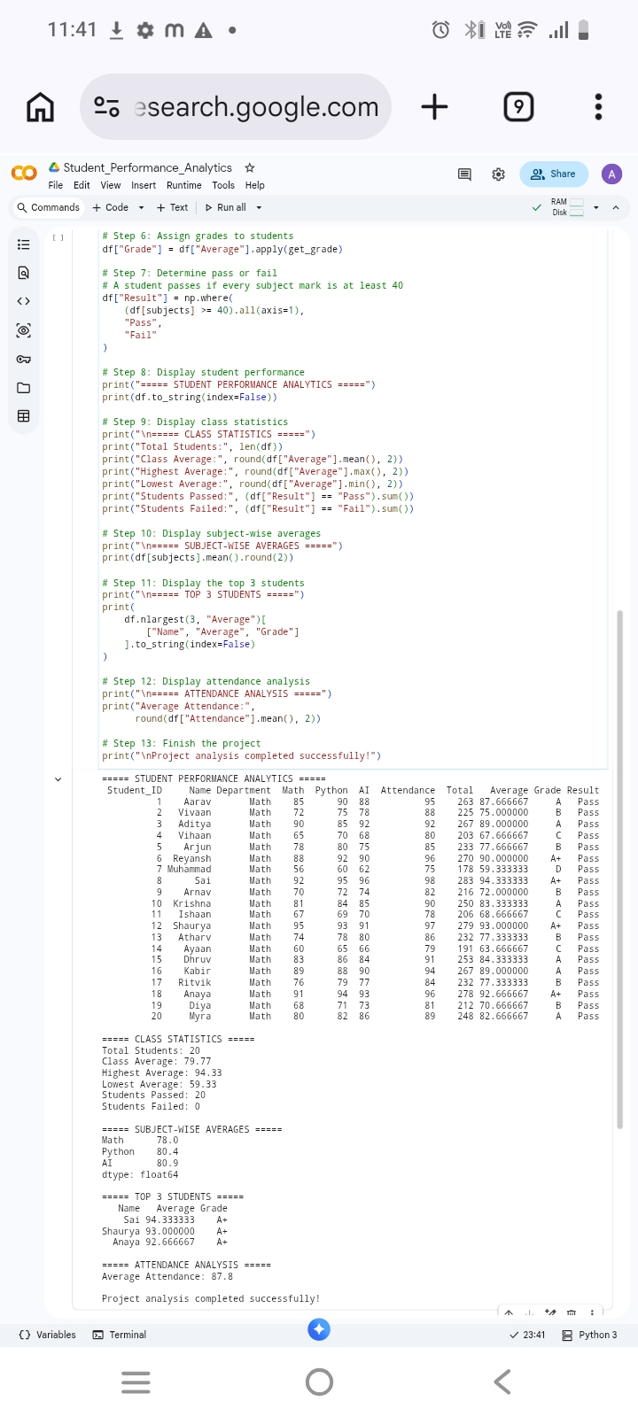

9. Conclusion
The Student Performance Analytics System demonstrates how Python, Pandas, and NumPy can be used to process student data and produce useful performance summaries. It automates grade calculation, pass/fail classification, class statistics, subject comparisons, top-performer identification, and attendance analysis.

10. Future Improvements
Possible improvements include validating missing or incorrect data, allowing users to enter new student records, generating charts, and exporting the analysis results to a new CSV file.

